CSCS 351: Software Quality Assurance

Assignment 1

Name: Muhammad Muzammil

Roll Number: 231485432

Section: A

Teacher: Saad Bin Saleem

**Test 1:**

This test case uses unit testing to check for failures. It tests for 3 data sets and tell us how many are failures. Doctest is used in this code.

This is the code for the test case.

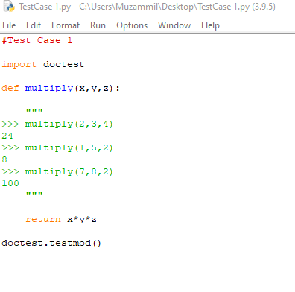

This is the result which tells us there are 2 failures. 2 data sets are not giving the right results.

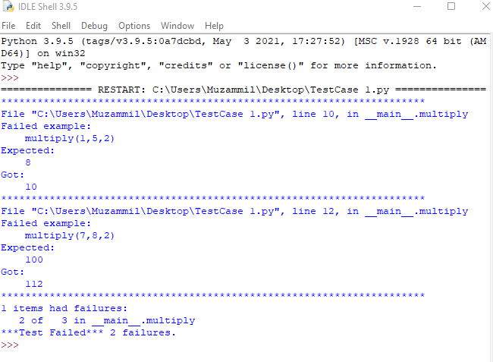

**Test 2:**

This test case uses unit testing to check for failures. It tests for 3 data sets and tell us how many are failures. Doctest is used in this code.

This is the code for the test case.

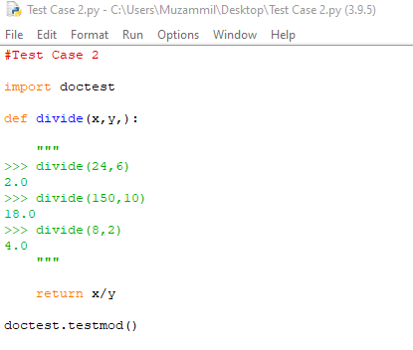

This is the result which tells us there are 2 failures. 2 data sets are not giving the right results.

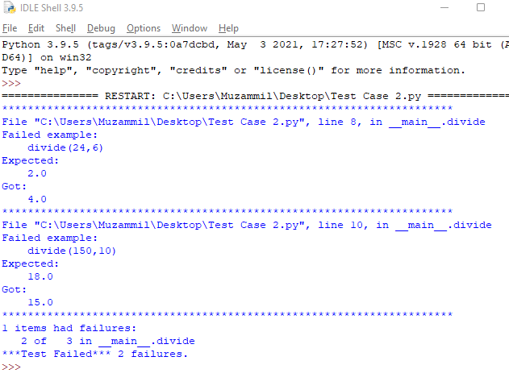

**Test 3:**

This test case uses unit testing to check for failures. It tests for 3 data sets and tell us how many are failures. Doctest is used in this code.

This is the code for the test case.

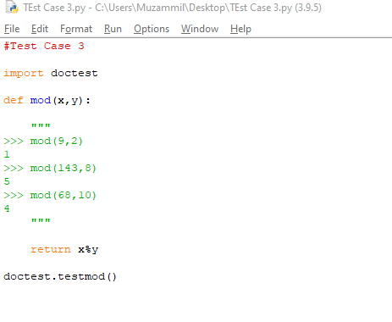

This is the result which tells us there are 2 failures. 2 data sets are not giving the right results.

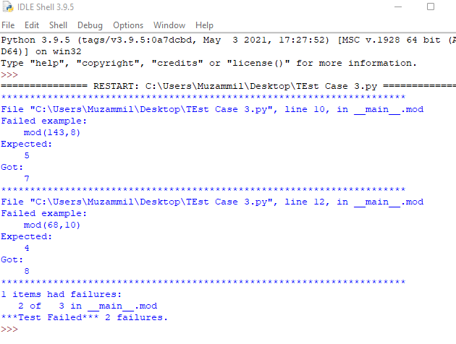

**Test 4:**

This test case uses unit testing to check for failures. It tests for 3 data sets and tell us how many are failures. Doctest is used in this code.

This is the code for the test case.

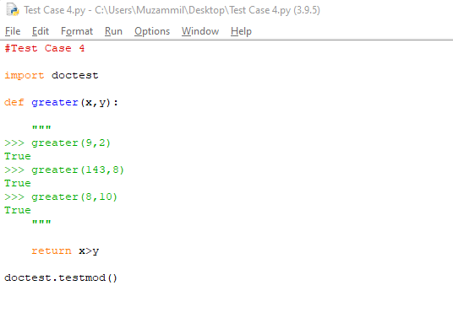

This is the result which tells us there are 1 failure1. 1 data set is not giving the right result.

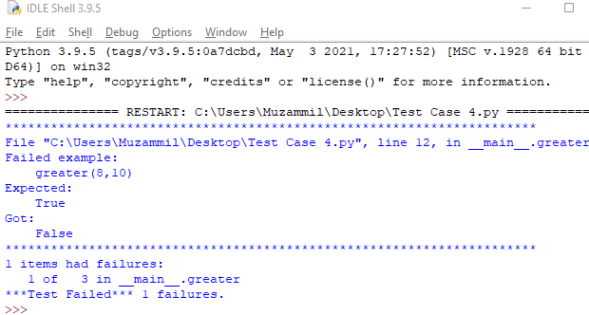

**Test 5:**

This test case uses unit testing to check for failures. It tests for 3 data sets and tell us how many are failures. Doctest is used in this code.

This is the code for the test case.

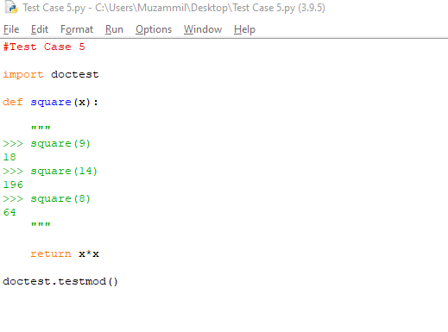

This is the result which tells us there are 1 failure. 1 data set is not giving the right result.

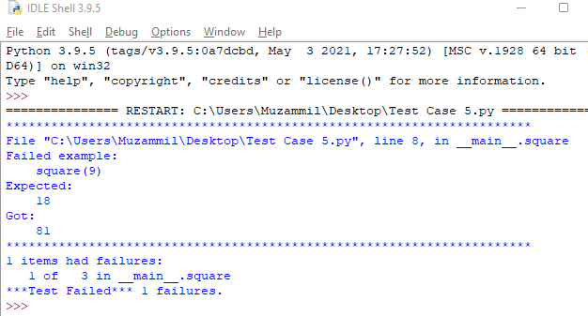

**Test Suite:**

**#Test Case 1**

import doctest

def multiply(x,y,z):

"""

>>> multiply(2,3,4)

24

>>> multiply(1,5,2)

8

>>> multiply(7,8,2)

100

"""

return x*y*z

doctest.testmod()

**#Test Case 2**

import doctest

def divide(x,y,):

"""

>>> divide(24,6)

2.0

>>> divide(150,10)

18.0

>>> divide(8,2)

4.0

"""

return x/y

doctest.testmod()

**#Test Case 3**

import doctest

def mod(x,y):

"""

>>> mod(9,2)

1

>>> mod(143,8)

5

>>> mod(68,10)

4

"""

return x%y

doctest.testmod()

**#Test Case 4**

import doctest

def greater(x,y):

"""

>>> greater(9,2)

True

>>> greater(143,8)

True

>>> greater(8,10)

True

"""

return x>y

doctest.testmod()

**#Test Case 5**

import doctest

def square(x):

"""

>>> square(9)

18

>>> square(14)

196

>>> square(8)

64

"""

return x*x

doctest.testmod()

**This is the final result of all 5 tests.**

